DAY 5

1. In day four we made so that the fillable error is gone. But to do it in a correct manner we can do this in



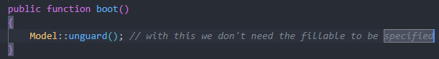

1. Creating Flash messages with alpine js

* We also added the link to our layout



* First we added the message in our controller



* Then we create new flash-message component

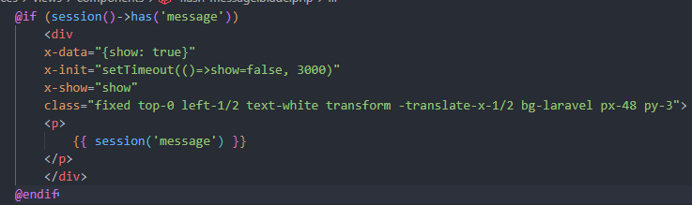

The data show there is from alpine js

* Then we defined the component in our layout



1. Keeping old data in form

* When submitting the data and form validation the values were disappearing
* So to fix it we added this value code to every input

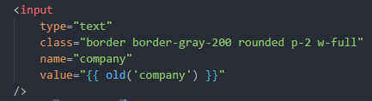

1. In our controller, changing the get to paginate and passing value will paginate frrrr

* 
* We can change pages with the url



* But to implement pagination it is easy as hell
* In the index we do this

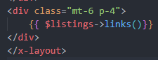

* And this gives pagination frrrr



* We can also change the style by just doing this



* And this will give us

and 

* This uses the tailwind by default, but to edit this we need to publish that using



  
and we can edit the format there

1. File uploads

* We need to change the form so that it can take in the images



* We also added the validations and old data code
* In the migration we added this



* In our controller

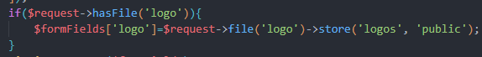

This will save the image to the storage public logos folder and path to the database

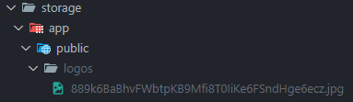

* We have access to the image using the url



* But not public to upload. We also need to link the storage using this command



* So to show the images we did this

